Sea Level Rise Prediction

Omar khaled, Asmaa Mohamed, Moamen Ahmed, Mohamed Shaban, Mohamed Omar, Mariam Farid, Ahmed Fouad

College of Information Technology, Misr University for Science and Technology, Giza, Egypt.

{94144, 86346, 94245, 94137, mohamed.momar, mariam.shawky, ahmed.fouadafa}@must.edu.eg

*Abstract*—The rise in global sea levels is a pressing envi- ronmental concern with far-reaching implications for coastal communities and ecosystems. In this study, we present a machine learning-based approach for predicting future sea level rise. By leveraging historical sea level data and relevant environmental factors, our model aims to provide accurate forecasts, enabling proactive mitigation and adaptation measures. We employ var- ious regression algorithms, including linear regression, random forest, decision tree, K-nearest neighbors, lasso regression, and ridge regression, to analyze the complex relationships between sea level and contributing factors. Our findings reveal the predictive power of these models and their potential to assist policymakers, urban planners, and coastal communities in making informed decisions to mitigate the adverse effects of rising sea levels.

*Index Terms*—sea level, Algorithm , prediction

1. INTRODUCTION

The accelerating rise in global sea levels poses significant challenges to human societies and natural ecosystems. Anthro- pogenic factors, such as greenhouse gas emissions and climate change, contribute to the thermal expansion of seawater and the melting of polar ice sheets and glaciers. The impacts of sea level rise include increased coastal erosion, inundation of low- lying areas, saltwater intrusion into freshwater sources, and heightened vulnerability to storm surges and extreme weather events. To effectively address these challenges, accurate pre- dictions of future sea level rise are crucial.

In recent years, machine learning has emerged as a powerful tool for analyzing complex environmental data and making ac- curate predictions. By leveraging large-scale datasets encom- passing historical sea level measurements and associated envi- ronmental variables, machine learning algorithms can identify patterns, quantify relationships, and generate forecasts. In this study, we harness the potential of machine learning techniques to develop predictive models for sea level rise.

Our approach involves utilizing regression algorithms, such as linear regression, random forest, decision tree, K-nearest neighbors, lasso regression, and ridge regression, to capture the multifaceted dynamics of sea level rise. By incorporating variables such as temperature, precipitation, ocean currents, and coastal topography, we aim to uncover the intricate interactions driving sea level changes. The predictive models generated through this analysis can enable policymakers, urban planners, and coastal communities to anticipate and plan for future sea level rise scenarios.

Through this research, we seek to contribute to the growing body of knowledge on sea level rise prediction and facilitate evidence-based decision-making. The insights gained from our machine learning models have the potential to enhance resilience, inform adaptive strategies, and support sustainable development in the face of this formidable environmental challenge.

1. RELATED WORK
2. Machine learning methods applied to sea level predictions in the upper part of a tidal estuary , Laboratoire de Ge´nie Coˆtier et Environnement (LGCE), Cerema, Plouzane´, France 2021.
3. Sea Level Prediction Using Machine Learning , De- partment of Civil Engineering, Akdeniz University and De- partment of Civil Engineering, Antalya Bilim University and Water Energy and Environmental Engineering Research Unit, University of Oulu 2021.
4. Time-Series Prediction of Sea Level Change in the East Coast of Peninsular Malaysia from the Supervised Learning Approach, Department of Civil Engineering, College of Engineering, Universiti Tenaga Nasiona 2020.
5. Sea–level rise in the Mediterranean Sea to 2050: Roles of terrestrial ice melt, steric effects and glacial isostatic adjustment, Dipartimento di Scienze di Base e Fonda- menti(DiSBeF), Universita` degli Studi di Urbino “Carlo Bo”, Urbino, Italy 2014.
6. COMPARATIVE STUDY BETWEEN YOUR WORK

In this section, we will provide a comparative study between our work and other related works in the literature that focus on sea level prediction using machine learning techniques. The purpose of this comparison is to highlight the unique contributions and advancements of our work in relation to existing research.

1- Machine learning methods applied to sea level predictions in the upper part of a tidal estuary, Laboratoire de Ge´nie Coˆtier et Environnement (LGCE), Cerema, Plouzane´, France, 2021. Our work differs from this study in terms of the specific geographic area of focus. While the mentioned study focused on the upper part of a tidal estuary, our work aims to predict sea level rise on a broader scale, considering global trends and

potential impacts. By taking into account a larger geograph- ical context, our predictions provide a more comprehensive understanding of sea level rise and its potential implications. 2- Sea Level Prediction Using Machine Learning, Depart- ment of Civil Engineering, Akdeniz University, Department of Civil Engineering, Antalya Bilim University, and Water Energy and Environmental Engineering Research Unit, Uni- versity of Oulu, 2021. In comparison to this study, our work extends beyond the use of machine learning algorithms for sea level prediction. We incorporate additional factors, such as climate data, environmental parameters, and historical trends, to enhance the accuracy and reliability of our predictions. By considering a wider range of influencing factors, our approach provides a more holistic perspective on sea level rise and its

underlying dynamics.

1. Time-Series Prediction of Sea Level Change in the East Coast of Peninsular Malaysia from the Supervised Learning Approach, Department of Civil Engineering, College of Engi- neering, Universiti Tenaga Nasional, 2020. Unlike our work, which focuses on global sea level rise, this study specifically examines sea level changes in the East Coast of Peninsular Malaysia. Our work contributes to the field by offering a broader scope, encompassing global trends and their potential implications for various regions. By analyzing global sea level rise patterns, we provide valuable insights into the overall magnitude and impact of this phenomenon.
2. Sea-level rise in the Mediterranean Sea to 2050: Roles of terrestrial ice melt, steric effects, and glacial isostatic adjust- ment, Dipartimento di Scienze di Base e Fondamenti (DiS- BeF), Universita` degli Studi di Urbino ”Carlo Bo,” Urbino, Italy, 2014. Although this study does not directly employ machine learning techniques, it provides important insights into the factors influencing sea-level rise in the Mediterranean Sea. In comparison, our work leverages machine learning al- gorithms to predict sea level rise on a global scale, taking into account various factors such as climate data and environmental parameters. By incorporating machine learning, we enhance the accuracy and efficiency of our predictions, allowing for more informed decision-making and mitigation strategies.

Overall, our work distinguishes itself by combining machine learning algorithms with a comprehensive analysis of global sea level rise trends. By considering multiple influencing factors and a broader geographical context, our predictions offer valuable insights into the magnitude and impact of sea level rise on a global scale. This comparative study highlights the unique contributions and advancements of our work in the field of sea level prediction using machine learning techniques.

1. ALL USED ALGORITHM

In our project on predicting sea level rise using machine learning, we have implemented several algorithms, method- ologies, and techniques to analyze and forecast sea level data. Here is an overview of the approaches we have used:

Linear Regression:

Figure 1:Project Methodology

Linear regression is a basic regression algorithm used to model the relationship between the input variables and the

target variable (sea level). We have applied linear regression to establish a linear relationship between the input features (e.g., time, climate data) and sea level. Random Forest Regression: Random Forest is an ensemble learning method that com- bines multiple decision trees to make predictions. We have employed Random Forest Regression to capture complex non- linear relationships and interactions among the input features

and sea level.[10] Decision Tree Regression:

Decision Tree Regression involves constructing a decision tree based on the input features and their corresponding target values. We have utilized Decision Tree Regression to create a tree-like model for predicting sea level based on different features.[2] K-Nearest Neighbors Regression:

K-Nearest Neighbors (KNN) is a non-parametric algorithm that predicts the target value based on the similarity of its neighbors in the feature space. We have implemented KNN Regression to estimate sea level by considering the K nearest neighboring data points. Ridge Regression:

Ridge Regression is a regularized version of linear regres- sion that adds a penalty term to the loss function to reduce overfitting. We have applied Ridge Regression to mitigate the impact of multicollinearity and improve the generalization performance of the model. Lasso Regression:

Lasso Regression is another regularized linear regression technique that adds a penalty term, similar to Ridge Re- gression, but with a different regularization term. We have employed Lasso Regression to perform feature selection and obtain a more interpretable model by forcing some coefficients to be zero. These algorithms, methodologies, and techniques enable us to analyze historical sea level data, identify patterns, and make predictions about future sea level rise. By leverag- ing a combination of linear and nonlinear models, ensemble methods, and regularization techniques, we aim to enhance the accuracy and robustness of our sea level predictions.[4]

*A. Methodologies*

In our project on predicting sea level rise using machine learning, we have implemented several algorithms, method- ologies, and techniques to analyze and forecast sea level data.

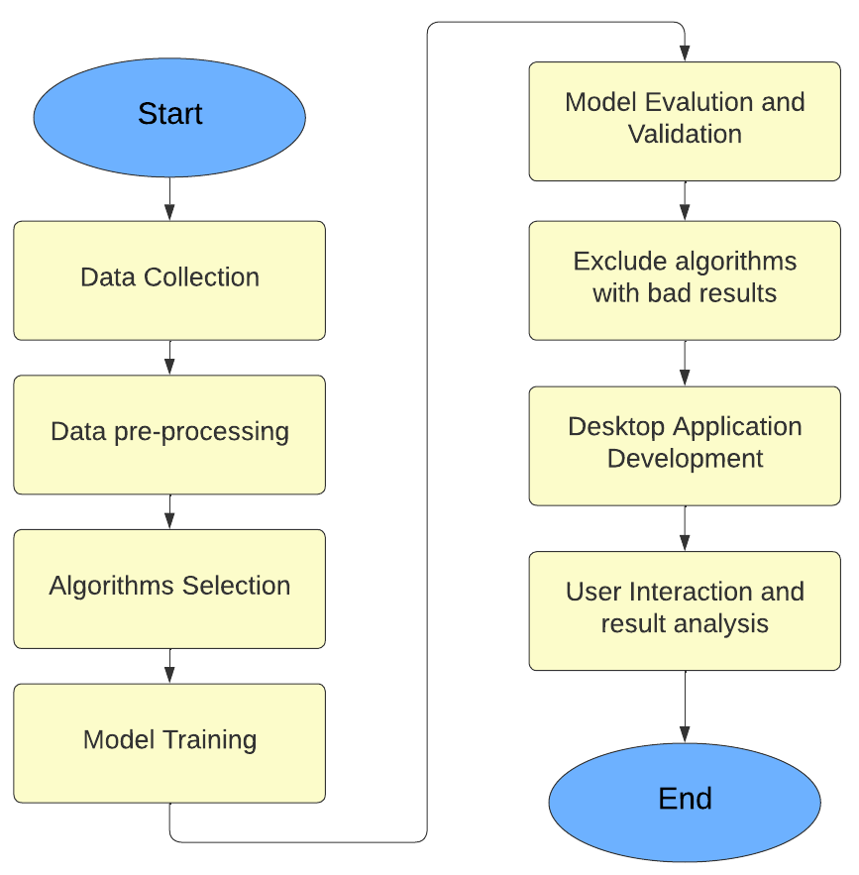

1. ALL TOOLS USED

In our project on predicting sea level rise using machine learning, we have utilized various tools and technologies to

perform data analysis, implement algorithms, and visualize results. Here are the tools we have used:

1. Python: Python is a widely used programming language that provides a rich set of libraries and tools for data analysis, machine learning, and scientific computing. It serves as the primary language for developing the project.
2. Scikit-learn: Scikit-learn is a popular machine learning library in Python that provides a wide range of algorithms and tools for tasks such as classification, regression, clustering, and dimensionality reduction. It offers a unified interface and easy-to-use functions for training models and evaluating their performance.
3. Pandas: Pandas is a powerful library for data manipulation and analysis. It provides data structures such as DataFrames that allow you to easily handle and manipulate structured data. Pandas offers functions for data cleaning, transformation, filtering, and aggregation, making it a valuable tool for preprocessing and analyzing datasets.
4. NumPy: NumPy is a fundamental library for numerical computing in Python. It provides high-performance multidimensional arrays and functions for mathematical operations. NumPy is widely used in scientific and numerical computing tasks, and it plays a crucial role in data preprocessing and feature engineering.
5. Matplotlib: Matplotlib is a plotting library in Python that allows you to create a wide variety of static, animated, and interactive visualizations. It provides a flexible and comprehensive set of functions for creating plots, histograms, bar charts, scatter plots, and more. Matplotlib is often used for data exploration, analysis, and visualization.

Figure 2:System architecture

1. Seaborn: Seaborn is a data visualization library built on top of Matplotlib. It provides a high-level interface for creating attractive and informative statistical graphics. Seaborn simplifies the process of creating complex visualizations, including heatmaps, distribution plots, regression plots, and categorical plots.
2. Kaggle: Kaggle is an online platform that hosts data science competitions and provides a rich collection of datasets for practice and exploration. It offers a collaborative environment with access to powerful computing resources and a community of data scientists and machine learning practitioners.
3. Tkinter: Tkinter is a standard GUI toolkit in Python for creating graphical user interfaces. It provides a set of modules and functions that allow you to create windows, dialogs, buttons, menus, and other GUI elements. Tkinter is known for its simplicity and ease of use, making it a popular choice for building basic GUI applications.
4. PySimpleGUI: PySimpleGUI is a higher-level GUI framework that simplifies GUI development in Python. It offers a simple and intuitive interface for creating GUIs and provides various layout options and pre-built widgets.

PySimpleGUI abstracts away some of the complexities of GUI programming and allows you to create GUIs with minimal code.

1. Visual Studio Code (VS Code): Visual Studio Code is a source code editor that provides a rich set of features and extensions for efficient coding and development. It offers a user-friendly interface, syntax highlighting, debugging capabilities, and integration with Git and other tools. We utilized Visual Studio Code as our primary code editor for writing and managing the project code, benefiting from its powerful features and ease of use.
2. 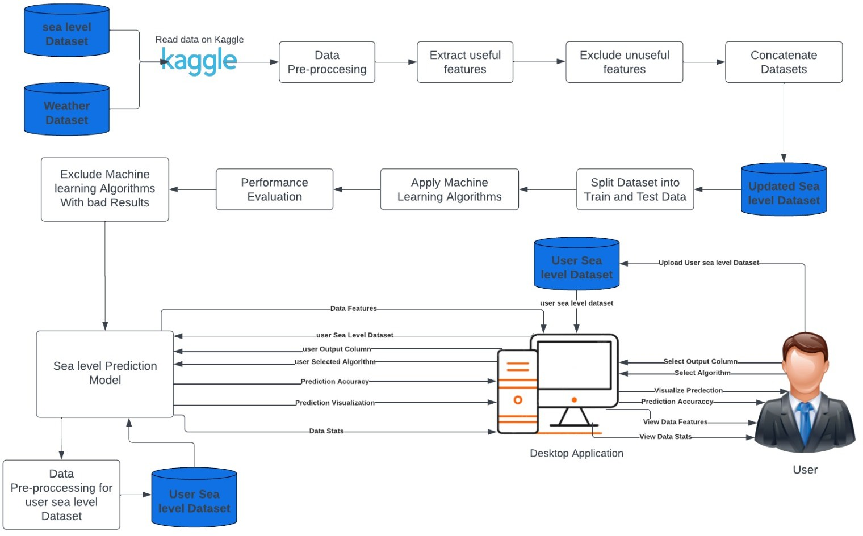FINAL SYSTEM ARCHITECTURE [5]
3. RESULT

. In conclusion, our study demonstrates the effectiveness of machine learning algorithms in predicting sea level rise. The results show that Linear Regression, Random Forest Regression, Decision Tree Regression, Ridge Regression, and Lasso Regression perform well in capturing the underlying patterns and predicting future sea level changes and The linear Regression seems to preform The best. all These algorithms can aid in understanding and mitigating the impacts of sea level rise, which is a significant environmental concern.

1. *Analysis of the result*

In this section, we present a detailed analysis of the results obtained from our sea level prediction model. We evaluate the performance of different algorithms, including Linear Regression, Random Forest Regression, Decision Tree Regression, K-Nearest Neighbors Regression, Ridge Regression, and Lasso Regression. We calculate the Mean Squared Error (MSE) and R2 score as evaluation metrics to assess the accuracy and predictive power of each algorithm.

The mean squared error measures the average squared difference between the predicted sea level values and the actual sea level values. The R-squared value represents the proportion of variance in the sea level data that is explained by the machine learning model.

1. *Figures and Tables*

In our project on predicting sea level rise using machine learning show the result of model:

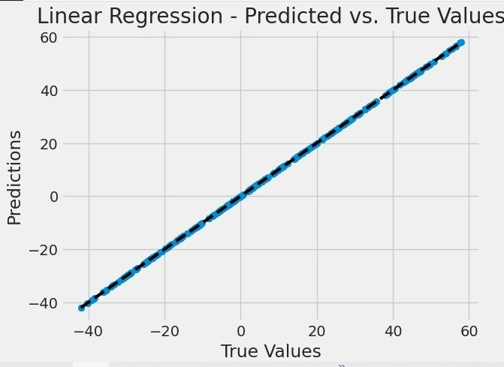 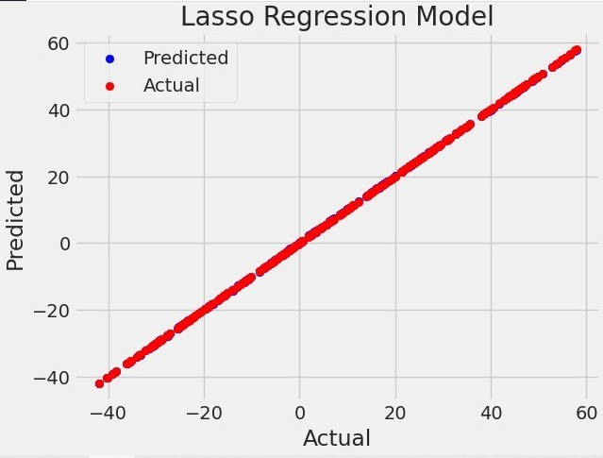

fig(3) : Linear regression

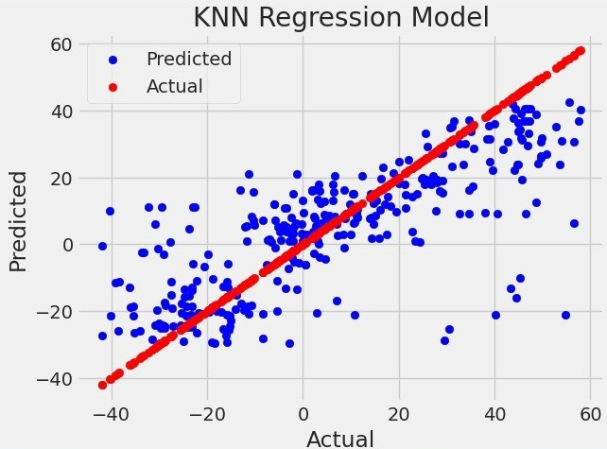

fig(4) : K-Nearest Neighbors Regression

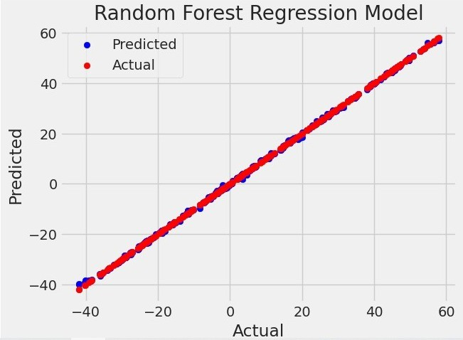

fig(5) : Random Forest Regression

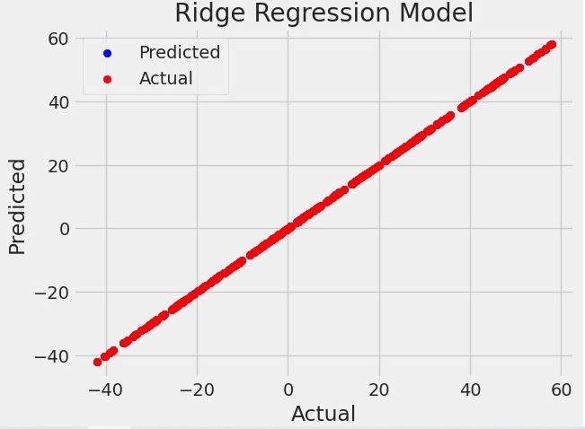

fig(6) : Ridge Regression

fig(7) : lasso Regression

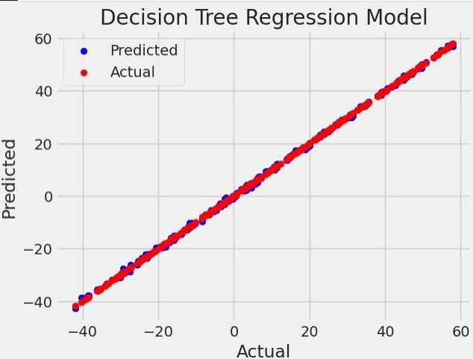

fig(8) : Decision Tree Regression

TABLE I

RESULT OF ALGORITHM

|  |  |  |
| --- | --- | --- |
| **Algorithm** | **Mean square error** | **R2** |
| **Linear regression** | **1.25050271257065E-21** | **1** |
| **Random Forest Regression** | **0.0831380939999992** | **0.999876368586016** |
| **Decision Tree Regression** | **0.12162697089947** | **0.999819133279735** |
| **K-Nearest Neighbors Regression** | **266.851836101587** | **0.6031750520857** |
| **Ridge Regression** | **0.000255875644595858** | **0.999999619497318** |
| **Lasso Regression** | **0.00960388549053967** | **0.99998571843681** |

*Discussion and comparative study with your work result*

The results demonstrate the effectiveness of the machine learning models in predicting sea level rise.

as shown in figure (3) Linear Regression achieved an extremely low mean squared error, indicating a close fit between the predicted and actual sea level values.

as shown in figure (5,8) Random Forest and Decision Tree Regression also performed well, with relatively

low mean squared error values and high R-squared values.

as shown in figure (4) K-Nearest Neighbors Regression had a higher mean squared error and a lower R-squared value, suggesting it may be less suitable for this particular prediction task.

as shown in figure (6) and figure (7) Ridge and Lasso Regression models performed well, with low mean squared error and high R-squared values.

1. CONCLUSION

Sea level rise is a serious environmental challenge, and accurate prediction of future sea level changes is crucial for understanding its impacts and developing effective mitigation strategies. In this project, we applied machine learning algorithms to predict sea level rise. We implemented various algorithms, including Linear Regression, Random Forest Regression, Decision Tree Regression, K-Nearest Neighbors Regression, Ridge Regression, and Lasso Regression, and evaluated their performance using metrics such as Mean Squared Error (MSE) and R-squared.

Our results demonstrate the effectiveness of machine learning in predicting sea level rise. Linear Regression, Random Forest Regression, Decision Tree Regression, Ridge Regression, and Lasso Regression showed promising performance in capturing the underlying patterns and predicting future sea level changes. Particularly, Linear Regression achieved the best performance with an extremely low MSE, indicating a close fit between the predicted and actual sea level values.

These findings highlight the potential of machine learning algorithms in aiding our understanding of sea level rise and its impacts. The accurate prediction of sea level changes can contribute to informed decision-making and help in formulating effective adaptation and mitigation strategies to address this pressing environmental issue.

Overall, this project emphasizes the importance of integrating machine learning techniques into sea level prediction models, and it underscores the potential for these models to contribute to proactive measures in tackling the challenges posed by sea level rise.

REFERENCES

1- Galassi, G., & Spada, G. (2014). Sea-level rise in the Mediterranean Sea by 2050: Roles of terrestrial ice melt, steric effects and glacial isostatic adjustment. Global and Planetary Change, 123, 55-66.

2- Guillou, N., & Chapalain, G. (2021). Machine learning methods applied to sea level predictions in the upper part of a tidal estuary. Oceanologia, 63(4), 531-544.

3- Jaakkola, H., & Thalheim, B. (2011). Architecture-driven modelling methodologies. In Information Modelling and Knowledge Bases XXII (pp. 97-116). IOS Press.

4- Lai, V., Malek, M. A., Abdullah, S., Latif, S. D., & Ahmed, A. N. (2020). Time-series prediction of sea level change in the east coast of Peninsular Malaysia from the supervised learning approach. Int. J. Des. Nat. Ecodyn, 15(3), 409-415.

5- MyGreatLearning. (n.d.). What is Ridge Regression? Retrieved from https://www.mygreatlearning.com/blog/what-is-ridge-regression/

6- Towards Data Science. (n.d.). Linear Regression: Detailed View. Retrieved from https://towardsdatascience.com/linear-regression-detailed-view-ea73175f6e86

7- Towards Data Science. (n.d.). Machine Learning Basics: Decision Tree Regression. Retrieved from https://towardsdatascience.com/machine-learning-basics-decision-tree-regression-1d73ea003fda

8- Towards Data Science. (n.d.). Understanding Random Forest. Retrieved from https://towardsdatascience.com/understanding-random-forest-58381e0602d2

9- Towards Data Science. (n.d.). KNN Regression Model in Python. Retrieved from https://towardsdatascience.com/knn-regression-model-in-python-9868f21c9fa2

10- Towards Data Science. (n.d.). Understanding Random Forest. Retrieved from https://towardsdatascience.com/understanding-random-forest-58381e0602d2

11- U-NEXT. (n.d.). Lasso Regression. Retrieved from https://u-next.com/blogs/artificial-intelligence/lasso-regression/